**MODELO LÓGICO**

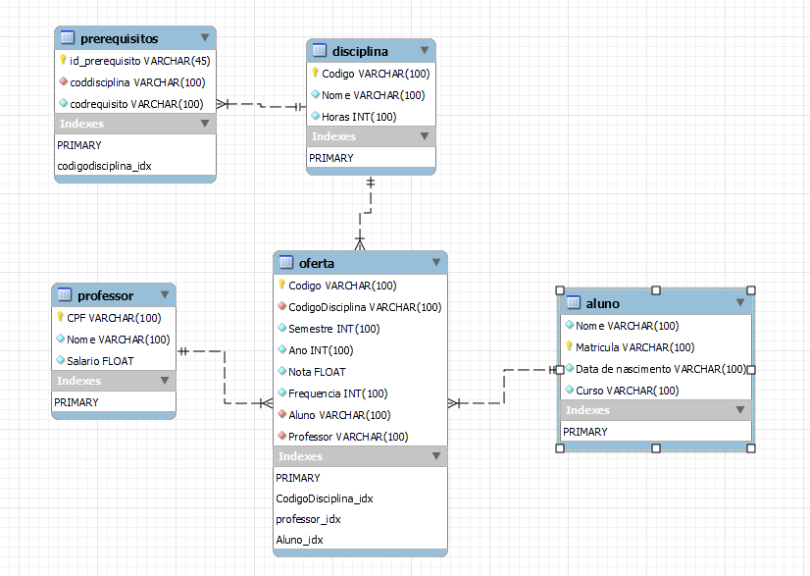

**MODELO CONCEITUAL**

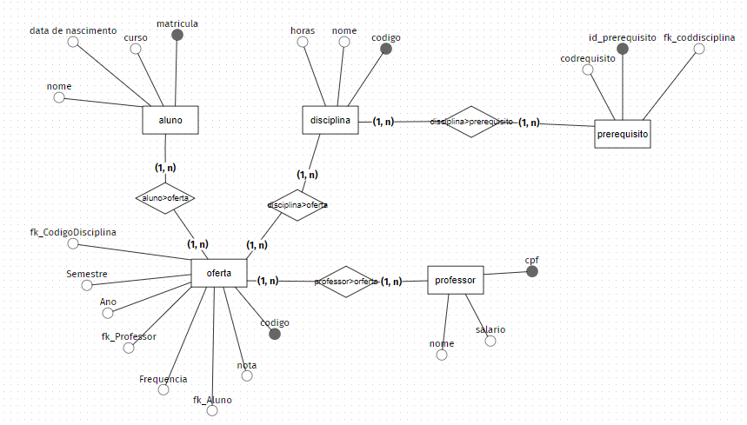

**Forward Engineering**

| **MySQL Workbench Forward Engineering**  **SET @OLD_UNIQUE_CHECKS=@@UNIQUE_CHECKS, UNIQUE_CHECKS=0;**  **SET @OLD_FOREIGN_KEY_CHECKS=@@FOREIGN_KEY_CHECKS, FOREIGN_KEY_CHECKS=0;**  **SET @OLD_SQL_MODE=@@SQL_MODE, SQL_MODE='ONLY_FULL_GROUP_BY,STRICT_TRANS_TABLES,NO_ZERO_IN_DATE,NO_ZERO_DATE,ERROR_FOR_DIVISION_BY_ZERO,NO_ENGINE_SUBSTITUTION';**  **-- -----------------------------------------------------**  **-- Schema mydb**  **-- -----------------------------------------------------**  **-- -----------------------------------------------------**  **-- Schema universidade**  **-- -----------------------------------------------------**  **-- -----------------------------------------------------**  **-- Schema universidade**  **-- -----------------------------------------------------**  **CREATE SCHEMA IF NOT EXISTS `universidade` DEFAULT CHARACTER SET utf8mb4 ;**  **USE `universidade` ;**  **-- -----------------------------------------------------**  **-- Table `universidade`.`aluno`**  **-- -----------------------------------------------------**  **CREATE TABLE IF NOT EXISTS `universidade`.`aluno` (**  **`Nome` VARCHAR(100) NOT NULL,**  **`Matricula` VARCHAR(100) NOT NULL,**  **`Data de nascimento` VARCHAR(100) NOT NULL,**  **`Curso` VARCHAR(100) NOT NULL,**  **PRIMARY KEY (`Matricula`))**  **ENGINE = InnoDB**  **DEFAULT CHARACTER SET = utf8mb4;**  **-- -----------------------------------------------------**  **-- Table `universidade`.`disciplina`**  **-- -----------------------------------------------------**  **CREATE TABLE IF NOT EXISTS `universidade`.`disciplina` (**  **`Codigo` VARCHAR(100) NOT NULL,**  **`Nome` VARCHAR(100) NOT NULL,**  **`Horas` INT(100) NOT NULL,**  **PRIMARY KEY (`Codigo`))**  **ENGINE = InnoDB**  **DEFAULT CHARACTER SET = utf8mb4;**  **-- -----------------------------------------------------**  **-- Table `universidade`.`professor`**  **-- -----------------------------------------------------**  **CREATE TABLE IF NOT EXISTS `universidade`.`professor` (**  **`CPF` VARCHAR(100) NOT NULL,**  **`Nome` VARCHAR(100) NOT NULL,**  **`Salario` FLOAT NOT NULL,**  **PRIMARY KEY (`CPF`))**  **ENGINE = InnoDB**  **DEFAULT CHARACTER SET = utf8mb4;**  **-- -----------------------------------------------------**  **-- Table `universidade`.`oferta`**  **-- -----------------------------------------------------**  **CREATE TABLE IF NOT EXISTS `universidade`.`oferta` (**  **`Codigo` VARCHAR(100) NOT NULL,**  **`CodigoDisciplina` VARCHAR(100) NOT NULL,**  **`Semestre` INT(100) NOT NULL,**  **`Ano` INT(100) NOT NULL,**  **`Nota` FLOAT NOT NULL,**  **`Frequencia` INT(100) NOT NULL,**  **`Aluno` VARCHAR(100) NOT NULL,**  **`Professor` VARCHAR(100) NOT NULL,**  **PRIMARY KEY (`Codigo`),**  **INDEX `CodigoDisciplina_idx` (`CodigoDisciplina` ASC) VISIBLE,**  **INDEX `professor_idx` (`Professor` ASC) VISIBLE,**  **INDEX `Aluno_idx` (`Aluno` ASC) VISIBLE,**  **CONSTRAINT `Aluno`**  **FOREIGN KEY (`Aluno`)**  **REFERENCES `universidade`.`aluno` (`Matricula`)**  **ON DELETE NO ACTION**  **ON UPDATE NO ACTION,**  **CONSTRAINT `CodigoDisciplina`**  **FOREIGN KEY (`CodigoDisciplina`)**  **REFERENCES `universidade`.`disciplina` (`Codigo`)**  **ON DELETE NO ACTION**  **ON UPDATE NO ACTION,**  **CONSTRAINT `professor`**  **FOREIGN KEY (`Professor`)**  **REFERENCES `universidade`.`professor` (`CPF`)**  **ON DELETE NO ACTION**  **ON UPDATE NO ACTION)**  **ENGINE = InnoDB**  **DEFAULT CHARACTER SET = utf8mb4;**  **-- -----------------------------------------------------**  **-- Table `universidade`.`prerequisitos`**  **-- -----------------------------------------------------**  **CREATE TABLE IF NOT EXISTS `universidade`.`prerequisitos` (**  **`id_prerequisito` VARCHAR(45) NOT NULL,**  **`coddisciplina` VARCHAR(100) NOT NULL,**  **`codrequisito` VARCHAR(100) NOT NULL,**  **PRIMARY KEY (`id_prerequisito`),**  **INDEX `codigodisciplina_idx` (`coddisciplina` ASC) VISIBLE,**  **CONSTRAINT `coddisciplina`**  **FOREIGN KEY (`coddisciplina`)**  **REFERENCES `universidade`.`disciplina` (`Codigo`)**  **ON DELETE NO ACTION**  **ON UPDATE NO ACTION)**  **ENGINE = InnoDB**  **DEFAULT CHARACTER SET = utf8mb4;**  **SET SQL_MODE=@OLD_SQL_MODE;**  **SET FOREIGN_KEY_CHECKS=@OLD_FOREIGN_KEY_CHECKS;**  **SET UNIQUE_CHECKS=@OLD_UNIQUE_CHECKS;** |
| --- |